HOW A WALTERS AND DOBSON FOOT PUMP WORKS
by
Gordon Edwards

Introduction
The Walters and Dobson foot pump – shown dismantled below – is an example of one of the very best of the high quality car tyre foot pumps made by various manufacturers in the first half of the 20th century.

It is of a beautiful double acting ‘pump in pump’ design, which, if properly maintained, delivers large quantities of air, very efficiently at high pressures.

It is shown dismantled in the picture below so a description can be given of the pumping and pressurization process employed in the pump. When assembled, the middle (smaller) piston in the picture below is inserted into the cylinder on the right, this assembly then being inserted into the large brass barrel on the left.

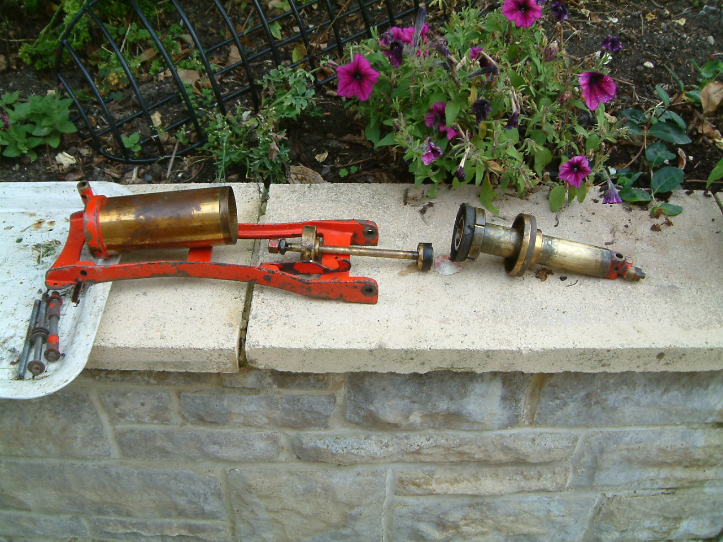

Step 1 of the Pumping Process
To describe the double acting pressurization process, we can follow the progress of a volume of air initially present in the large diameter barrel behind the large leather washer. As the foot pedal is depressed, the large piston on the right of the above picture compresses air in the brass barrel on the left.

Step 2 of the Pumping Process
The air being compressed in step1 above then enters a small hole in the piston rod of the small inner pump. The small hole is shown in the detailed picture below.

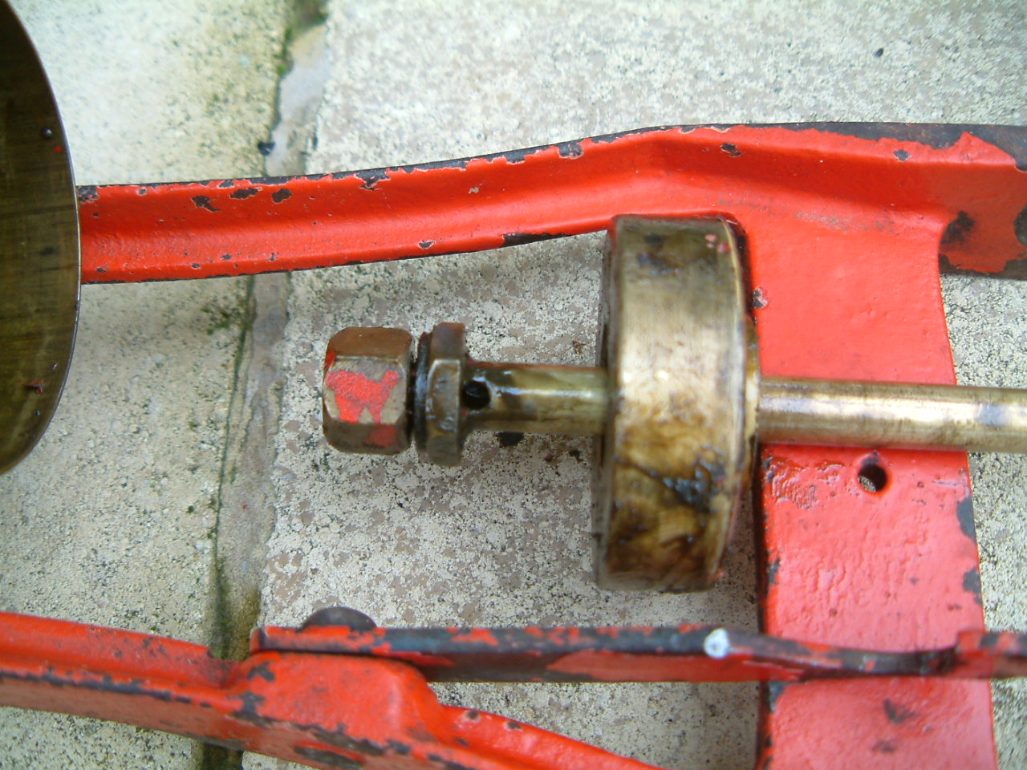

Step 3 of the Pumping Process
After entering the small hole, the compressed air travels along the inside of the piston rod – emerging via a non-return valve from another little hole at the other end of the rod - just behind the small piston. This second small hole and small piston are shown in the picture below. The volume of air we are considering has therefore moved and is now in place behind the small piston – with the foot pedal fully depressed.

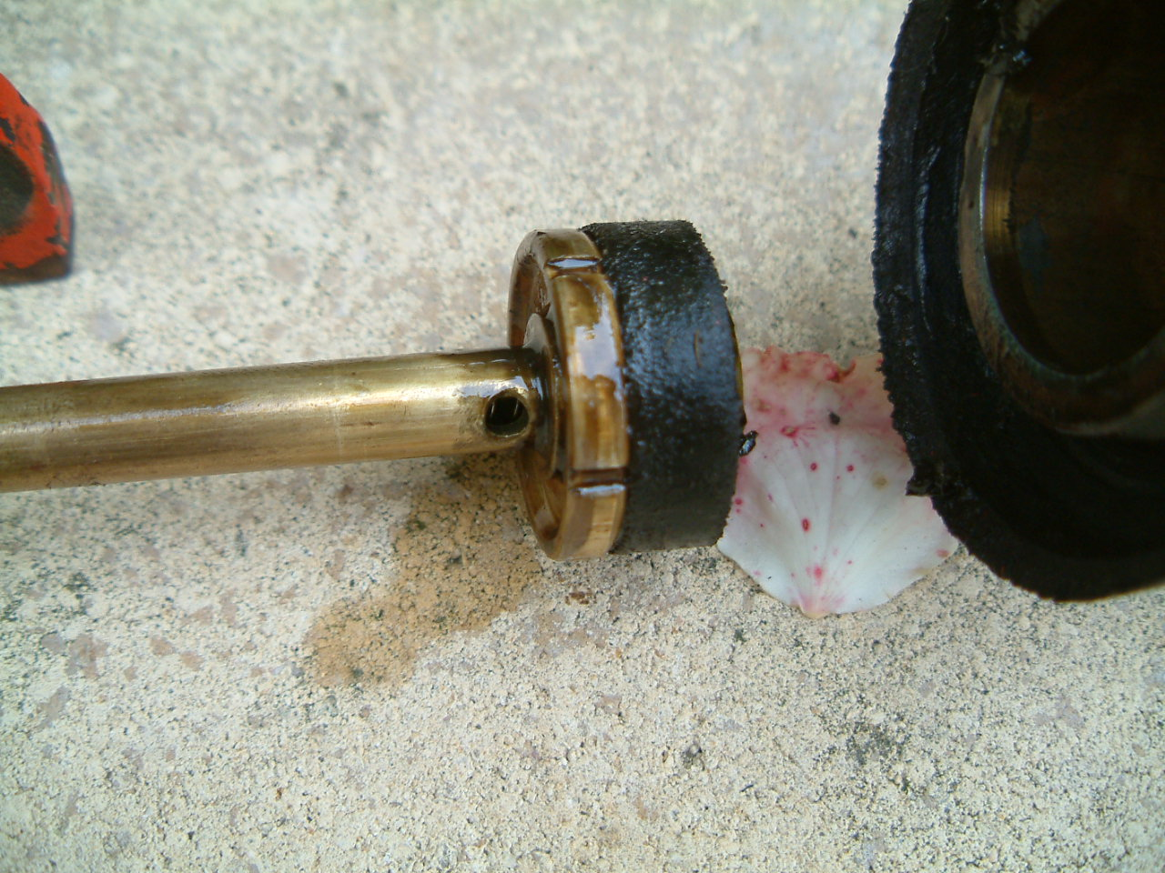

Step 4 of the Pumping Process
On the next upstroke of the foot pedal, the above volume of air passes through four slots in the brass back plate of the small piston, past its leather washer in a backwards direction, and then enters the compression chamber behind the small piston. Two of the slots in the back plate can be seen clearly in the picture above. The air is prevented returning up the piston rod at this point by a ball bearing and spring- acting as a non return valve in the piston rod. The spring can just be seen through the small hole in the picture above.

Step 5 of the Pumping Process
Our volume of air is now ready for its second stage pressurisation and delivery to a tyre. As the foot pedal is depressed again, the small piston compresses the volume of air for a second time and delivers it into the connecting hose through the outlet aperture– shown in the picture below. Note, adjacent to the outlet is a neat little arrangement – a schrader type vale attachment which allows the tyre pressure to be taken (using a separate pressure gauge) without disconnecting the hose.

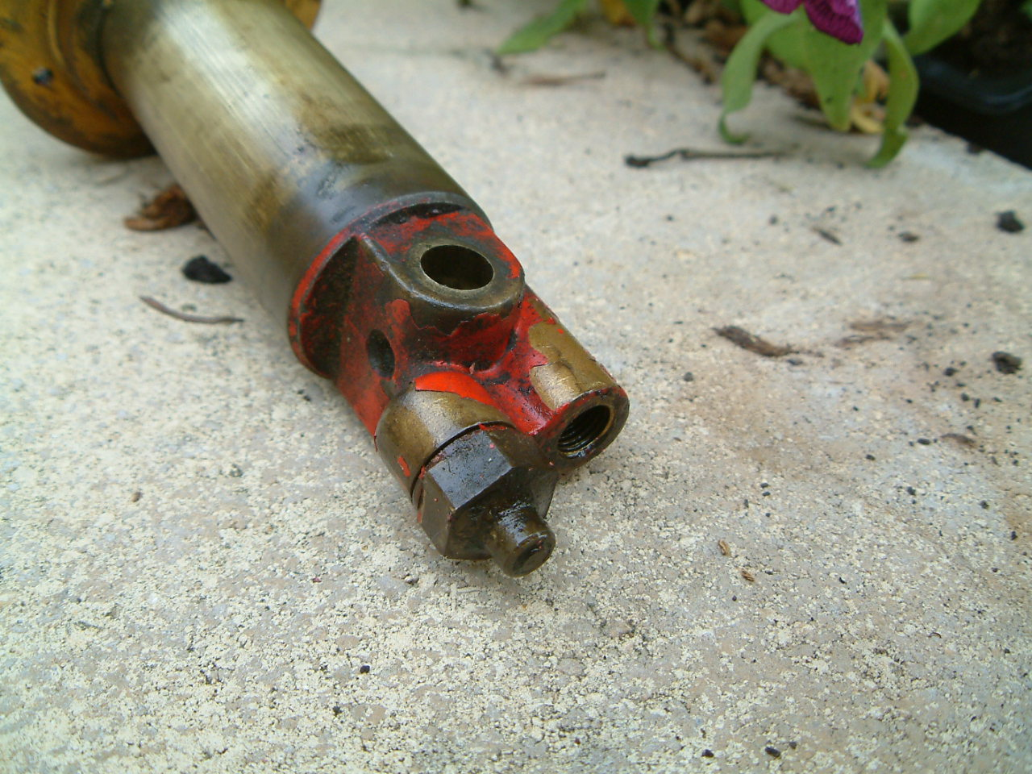

Overhaul and Maintenance
A full strip down of the pump is necessary to check and replace both leather piston washers. Also, the piston rod must be cleaned out internally and the functioning of the non return valve checked. Another key point for maintenance is the small airtight gland through which the piston rod slides. This is a tricky little beast to get out and replace but is crucial to the working of the pump. Many people attempting to overhaul the pump (without understanding the whole system) forget to replace this gland and are disappointed!

The overall design is complicated - but this is required to enable the high efficiency and pressure of which the pump is capable. It is an example of a beautiful piece of engineering design, when British engineering skills reigned supreme, and is designed to last many lifetimes! It presents a stark contrast to the flimsy tin foot pumps currently sold in Halfords and made in China – becoming known widely as ‘ankle breakers’.

Gordon Edwards (www.vintagepumps.co.uk)
August 2010

